**Setup New Nexus**

**Download the certificate :**

* Go to New nexus Url(Intranet Nexus), through offshoreportal
* Click on -> Not Secure -> Certificate -> Details -> copy to file -> Next -> Select “DER encoding” and Next -> browse and place the certificate where you have “**cacerts” inside jdk (eg:** C:\Program Files\Java\jdk1.8.0_271\jre\lib\security**)** and name as **nexus-intranet**.

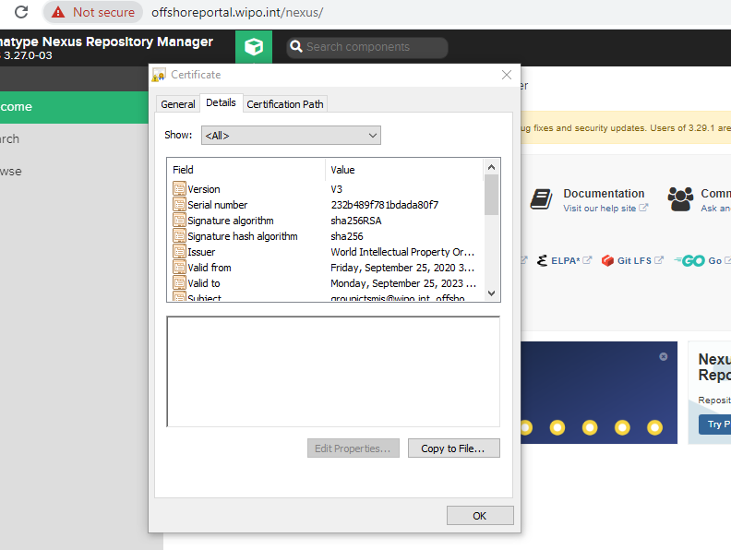

* Open CMD with Admin rights and go to the location where you have **cacerts(**C:\Program Files\Java\jdk1.8.0_271\jre\lib\security**)** and run the command “**keytool -import -alias nexus-intranet -file nexus-intranet.cer -keystore cacerts**” and enter the password “**changeit**”.

**Disclaimer :**

Check if it is successful.

If you face issue with keytool, please check if path is set for jre in your environment variable.

